Matua School payments now online with Kindo!

You can now pay your school expenses and order lunch from Pita Pit all online from our school website!

www.matua.school.nz - then click on the ‘Kindo Shop‘ button.

Ezlunch users
Our Kindo online school shop uses the same software as ezlunch.
NOTE: your login email address must match that held by the school so you can link to the school student management system. If not, change it on the My Details page or update the school.

- log in now using the same email and password
- click Fees and Donations and "link these students"
- match your children between Kindo and our school student system (eg. Zoe=Zoe).

You’re already sorted!

New users
Creating an account is easy and fast.

- Click on the ‘New users’ button on our school website Shop page.
- Enter in the email address the school has on file for you, and click ‘continue’. You will receive an email with a link.
- Click on the emailed link to enter in a password, tick to agree to the terms and conditions, and click ‘continue’.
- The registration process is now complete.

You only need to register once. Next time just log in with your email address and password.

Topping up your account
There are three ways you can choose to top-up your account, and this can be done either at the checkout, or by selecting the ‘my account’ button.

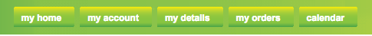
No Fees. Allow two days for transfer of funds.
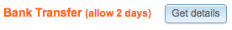

This is a great option for setting up automatic payments. It means you can add regular amounts over the year to ensure there are always funds available when you need them, or to build up funds for the bigger ticket items.
Instant Transfer. Two options available:
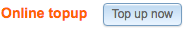

- Account2Account – No Fees, you will need your internet banking details.
- Debit and Credit Cards – Fees apply.

Select the option that best suits you and follow the prompts. The transfer is instant, so you order can be completed immediately.

You can choose to top up exactly the amount you need, or add extra to your account to ensure you have a speedy transaction next time.

Shopping
Items can be added to your shopping cart super fast for all children on one page.

- For personalized account items, click on next to an item under your child’s name to add to the cart. Some items allow you to adjust how much you’d like to pay first.

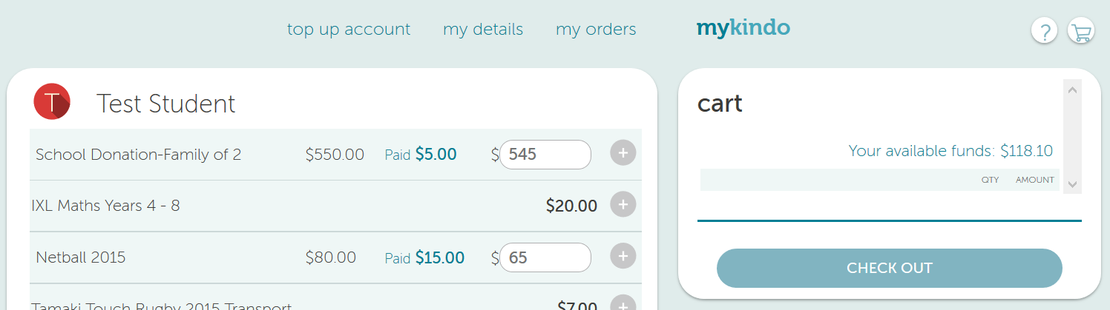

For shop (non-personalised) items, click the icon for the student requiring the item (eg. for Test Student). The icon will bold and display a quantity.
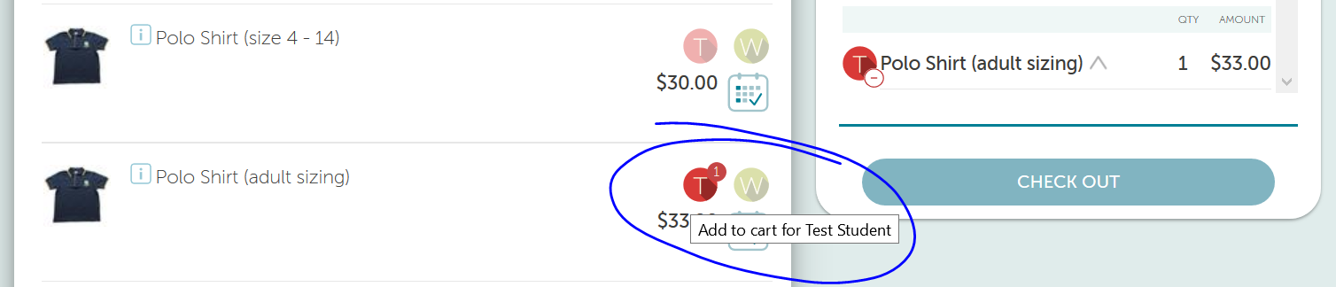

- If more information is needed, some questions may pop up for you to answer.

The items selected will then appear in the cart.

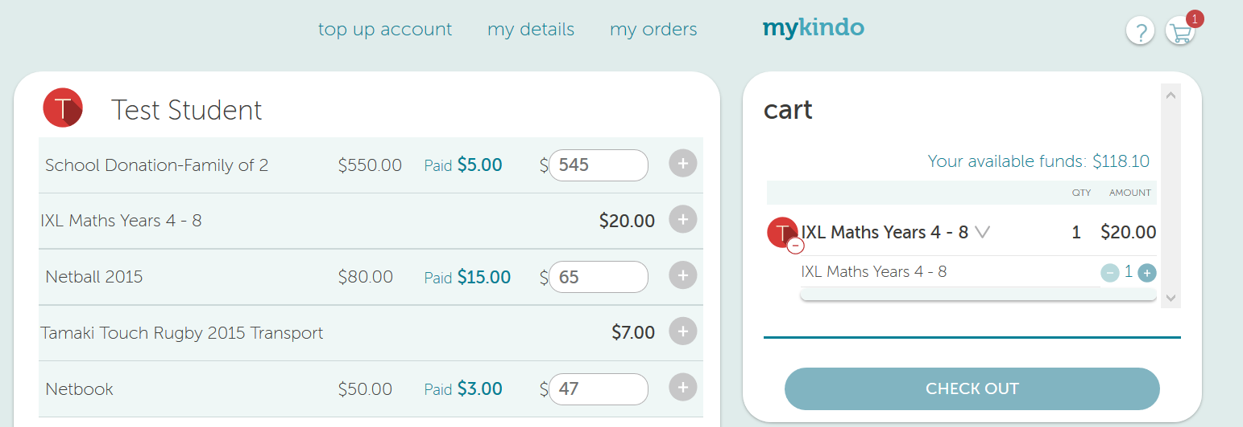
- Click V to expand the item.
- Using the buttons next to each item, you can add more or delete the item.

- When you have finished selecting items for your child’s order, click

- Providing there are sufficient funds in your account, click at the checkout and you’re done!

- If you have insufficient funds in you account, you will be prompted to top up your account first.

- Your payment will automatically go through to the School, and you will receive an email receipt confirming your payment or top-up.

